Fragments-UI GitHub:
https://github.com/MansoorAZafar/fragments-ui/tree/main
Fragments GitHub: https://github.com/MansoorAZafar/fragments

Page When NOT Logged in
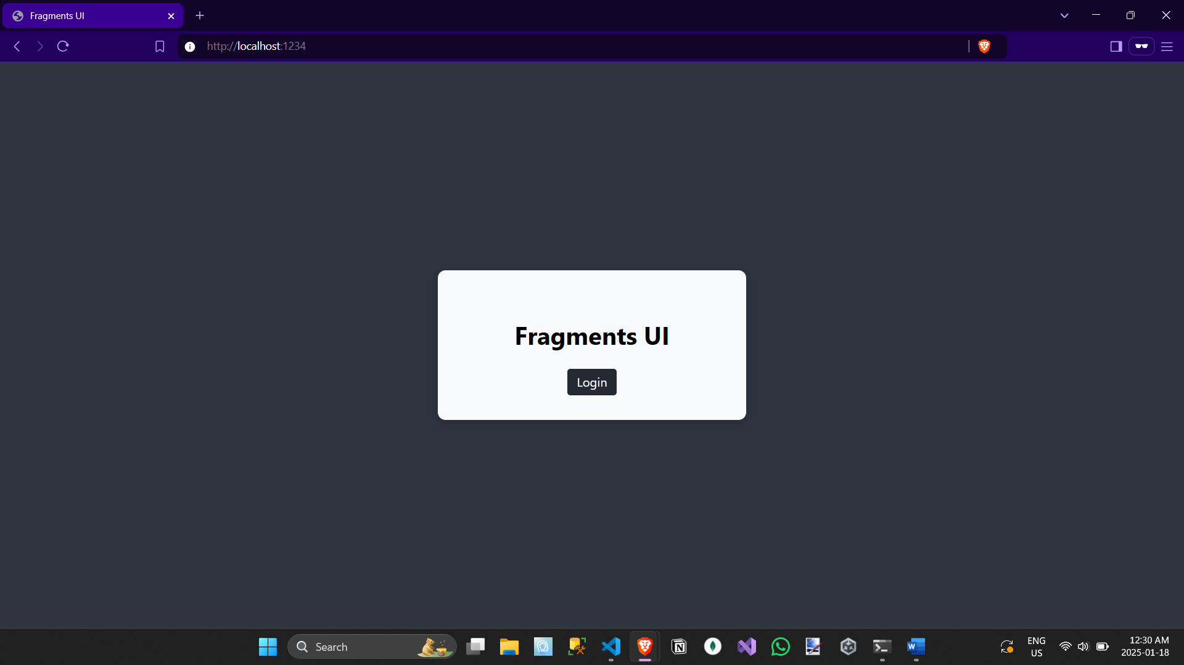
Clicking The Login Button
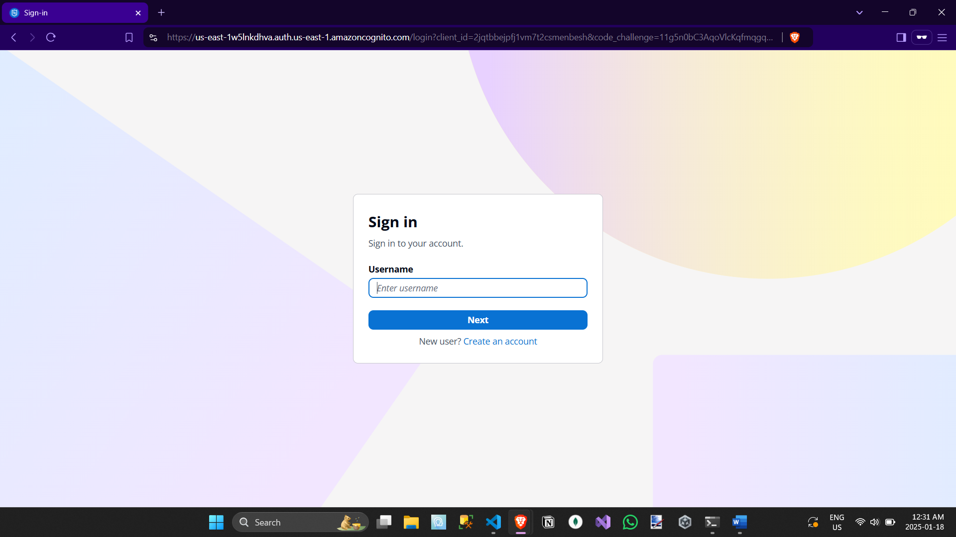
Page When Logged-in + Console
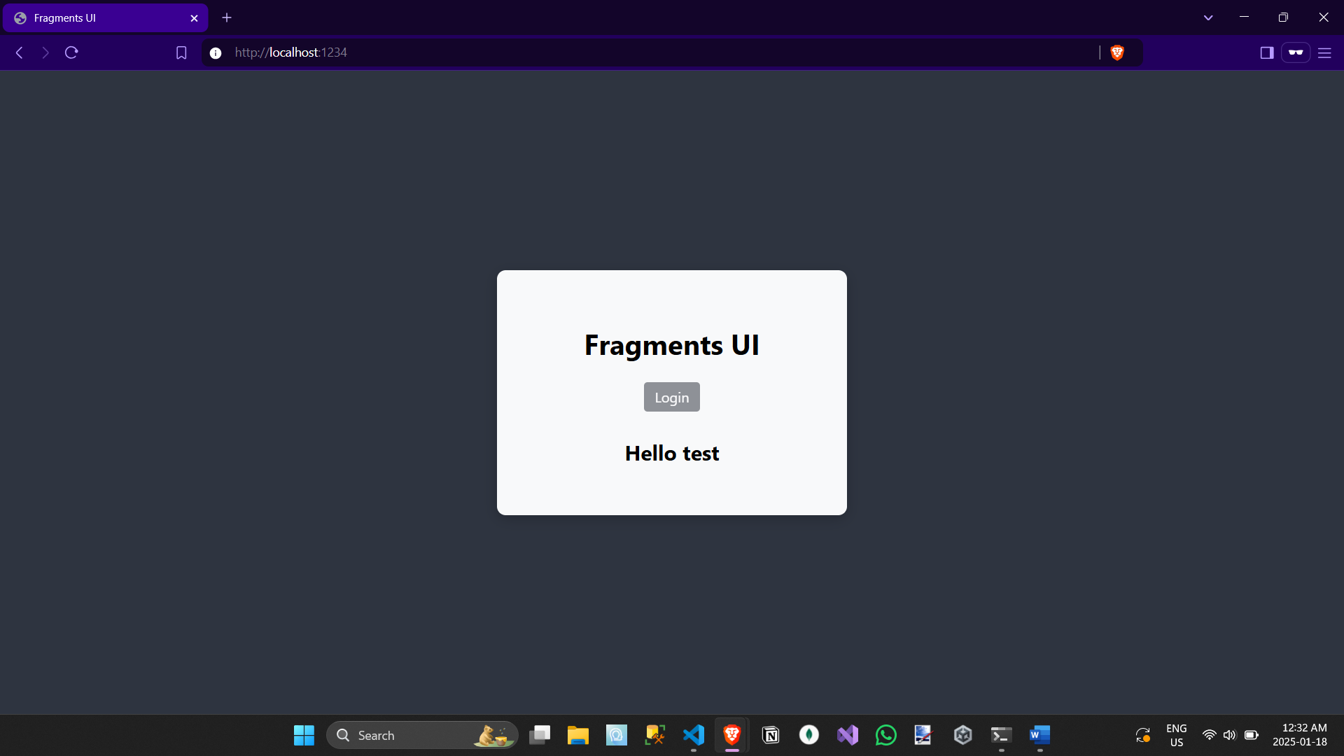
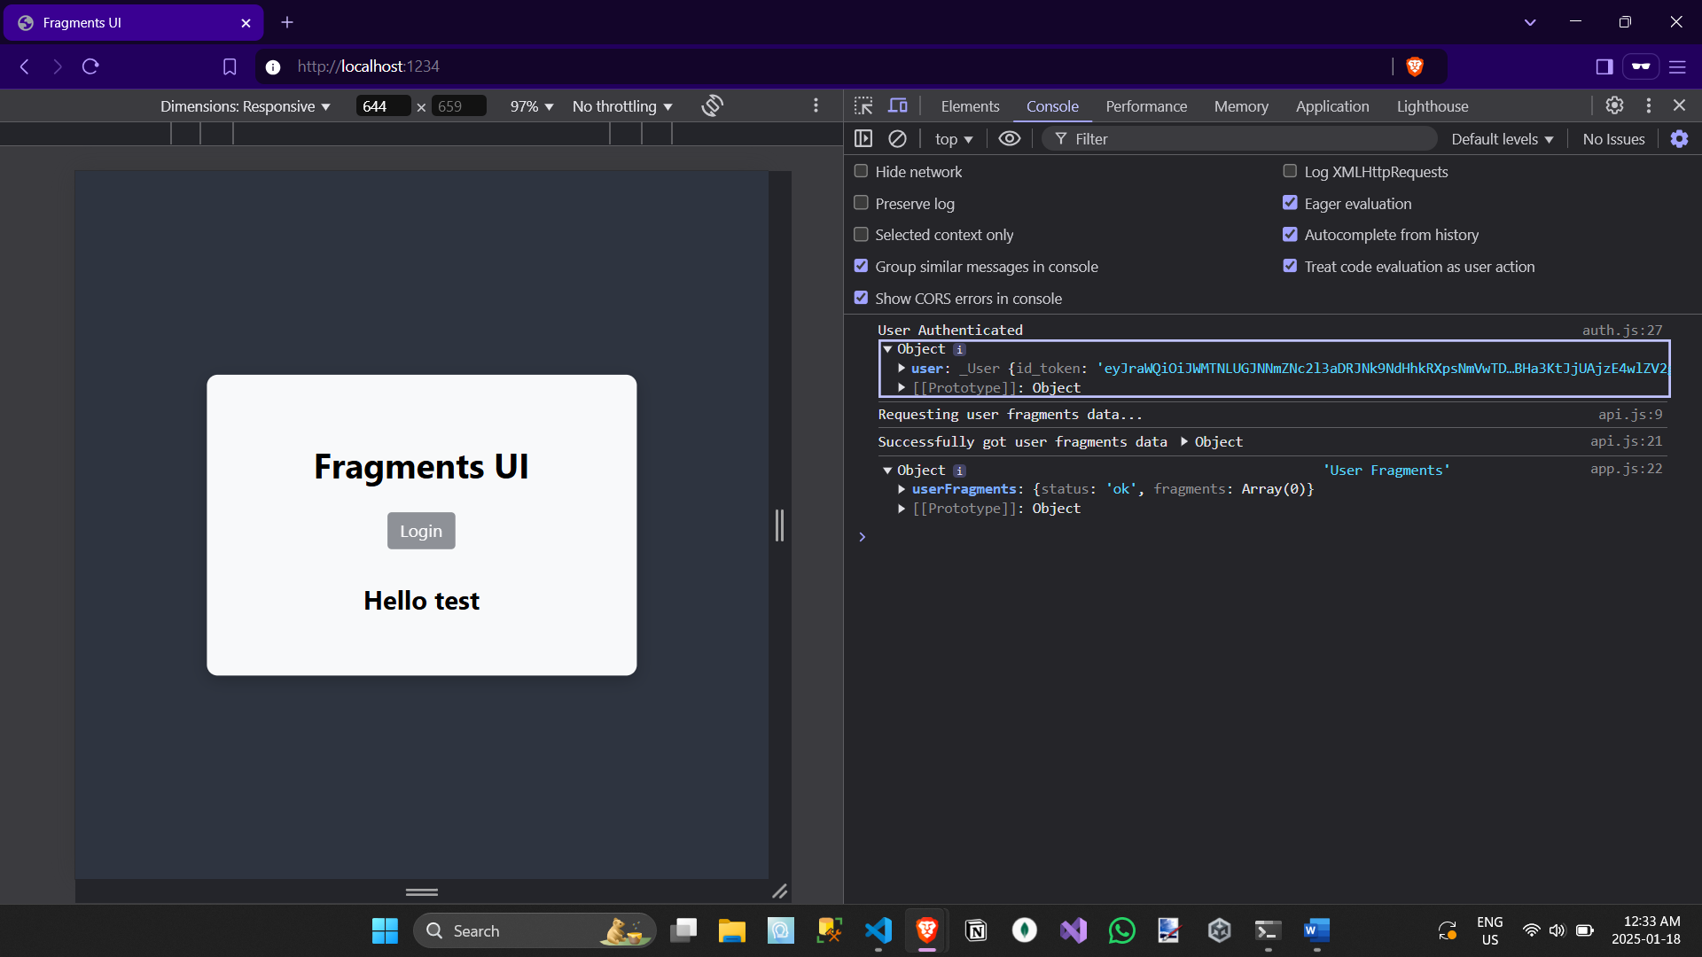
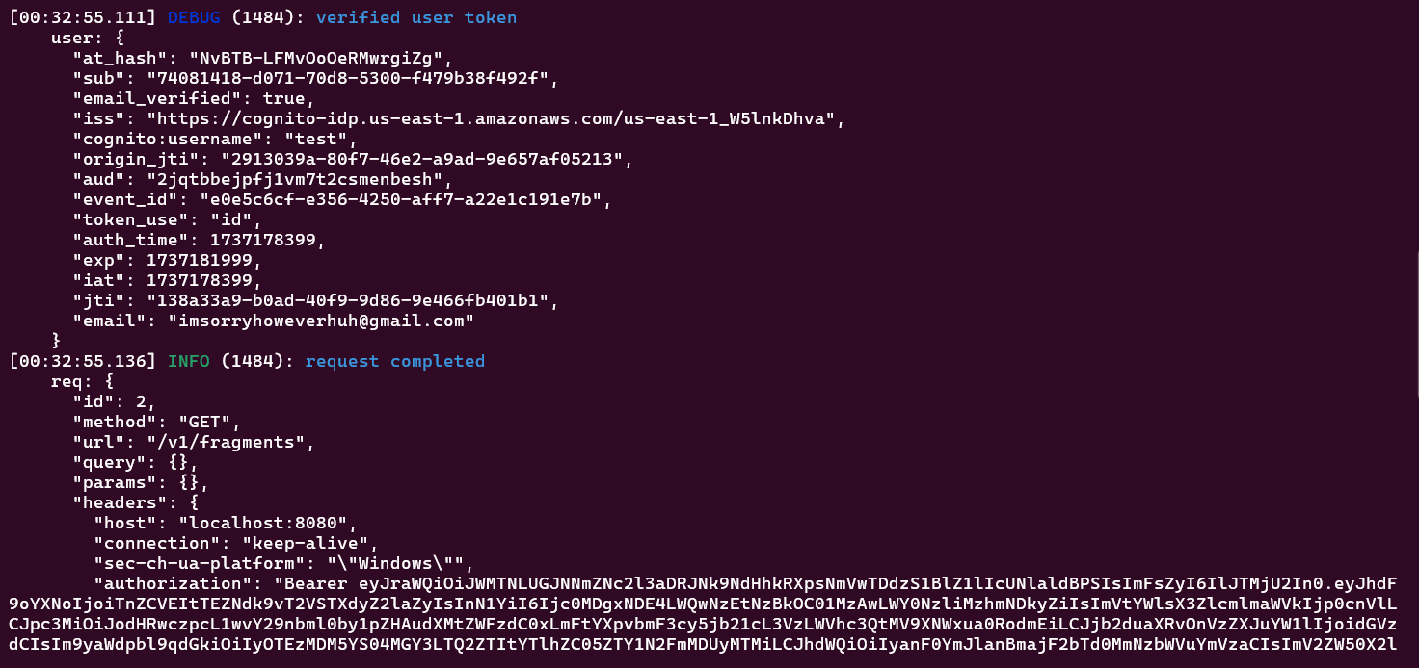
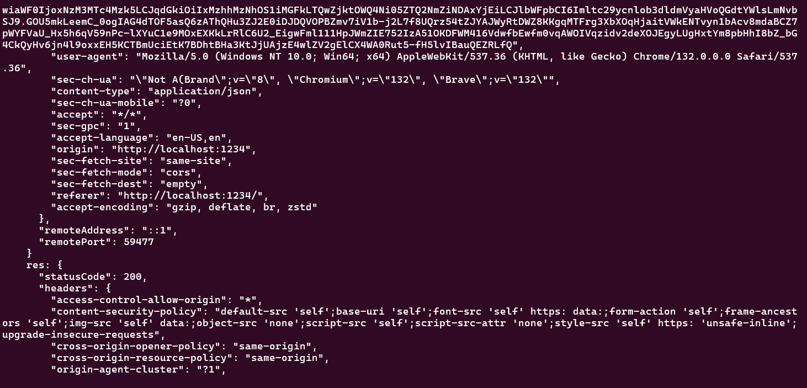
AWS Console Cognito Users
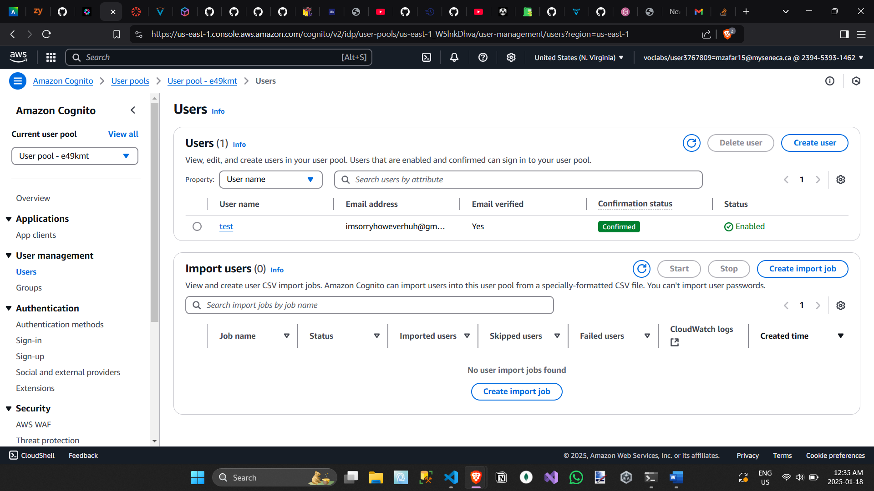
Fragments Cognito Server Starting
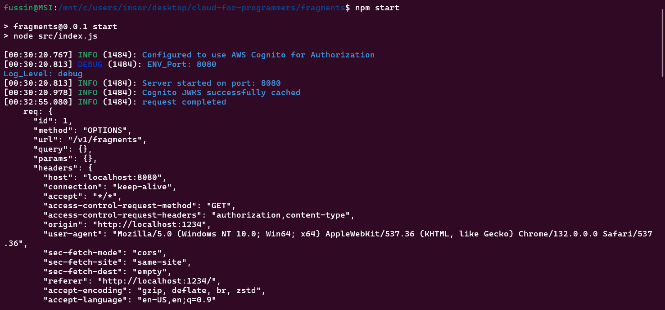
Authenticated User Successfully Accessing Protected Route
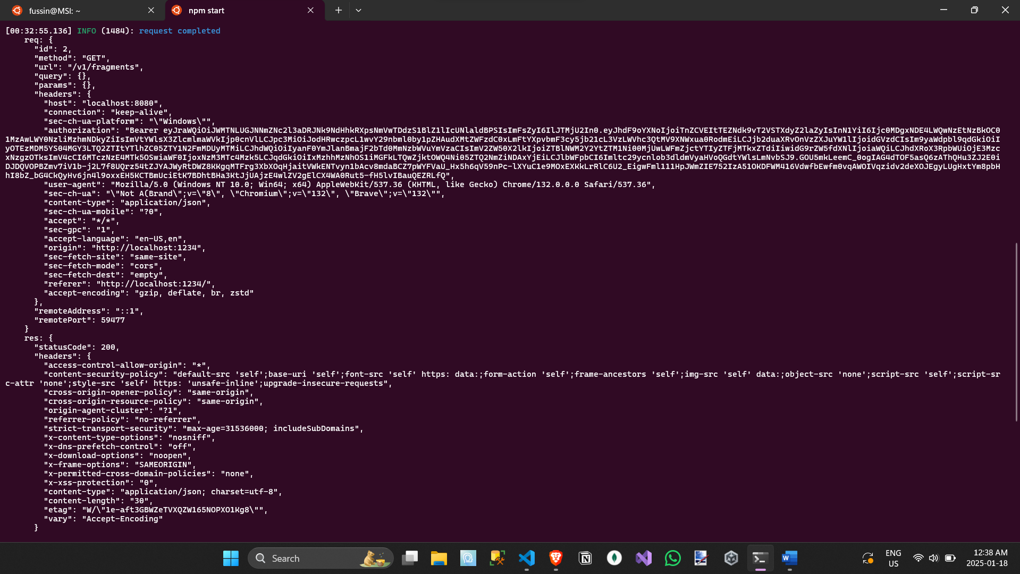
Unauthenticated User Attempting to Access Protected Route
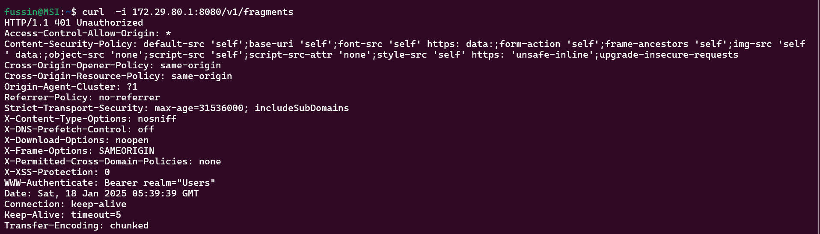
(Server Perspective)
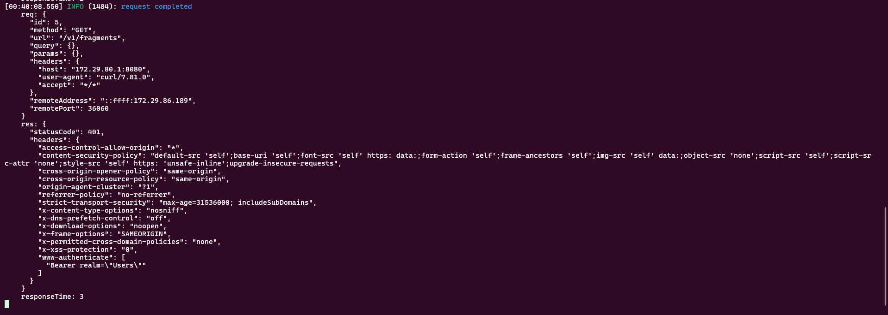
ID JWT Token Debugger
